Benessere Chiropractic

295 W. Broadway

Eugene, OR 97401

Ph: (541)636-3358 F: (541)636-3098

*****************************************************************
Chris Osterlitz,  D.C. | Katherine Kinports, D.C. | Erik Gurule-Long, D.C. | Sarah Pagen,  L.M.T.
Ann Cole, L.M.T. | Annie Siemens, L.M.T.
Patient Registration
Today’s Date_______________
Name___________________________ Date of Birth ______________
Address_________________________ Home Phone_______________
City______________State____Zip_____ Cell Phone________________
Social Security #____________M__F__ Work Phone_________________
Employer____________Occupation_________ email________________
Marital Status: S M W D P Spouse’s Name__________ # of children_______
How did you hear about us? ____________________________________
Emergency contact:_____________________ Phone:________________
I am here today due to: _Illness _Trauma _Work Injury _Auto Accident _Other
What date did this occur?________________

For Insured Patients
Primary Insurance for today’s visit: _Private Ins. _Auto _Work Comp _Medicare
Insurance Company: _________________________________________
Name of Insured:____________________ ID No: __________________
Group No:_________ Claim No:___________ Medicare No: ___________
Secondary Insurance Company:__________________________________
Name of Insured:______________________ ID No: ________________
Group No:________ Claim No:___________ Medicare No: ____________

I understand that health insurance policies are an arrangement between my insurance carrier and myself. Billing is done by Benessere as a courtesy only and all services rendered to me are my personal responsibility.

I authorize the release of any medical information necessary to process my insurance claim and I authorize payment of medical benefits to this office for professional services rendered.

Patient Signature:__________________________ Date:____________

Please check the symptoms that you have noticed in the last year:
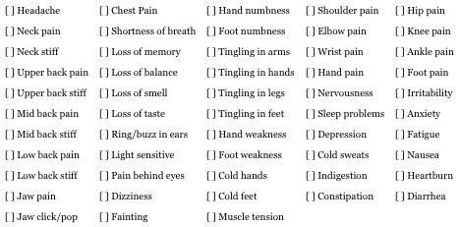
If other, describe: __________________________________________ _______________________________________________________
Is this appointment related to an accident or injury? (If billing auto insurance, please ask receptionist for auto form) [ ] No [ ] Yes, describe: ____________ _______________________________________________________

First priority for this appointment(body region):______________________
Cause of symptoms: _________________________________________
When did this condition start? __________________________________
Have you ever had similar symptoms in the past? When? ________________
What aggravates this condition? _________________________________
What relieves this condition? ___________________________________
Is this condition: [ ] Constant [ ] Getting progressively worse
[ ] Comes and goes [ ] Getting progressively better
Other doctors seen for this condition:______________________________
Response to treatment: _______________________________________

Second priority for this appointment:______________________________
Cause of symptoms: _________________________________________
When did this condition start?___________________________________
Have you ever had similar symptoms in the past? When?_________________
What aggravates this condition? _________________________________
What relieves this condition?____________________________________
Is this condition: [ ] Constant [ ] Getting progressively worse
[ ] Comes and goes [ ] Getting progressively better
Other doctors seen for this condition:______________________________
Response to treatment: _______________________________________

Third priority for this appointment: _______________________________
Cause of symptoms: _________________________________________
When did this condition start?___________________________________
Have you ever had similar symptoms in the past? When?_________________
What aggravates this condition? _________________________________
What relieves this condition?____________________________________
Is this condition: [ ] Constant [ ] Getting progressively worse
[ ] Comes and goes [ ] Getting progressively better
Other doctors seen for this condition:______________________________ Response to treatment: _______________________________________

Fourth priority for this appointment: ______________________________
Cause of symptoms: _________________________________________
When did this condition start?___________________________________
Have you ever had similar symptoms in the past? When?_________________
What aggravates this condition? _________________________________
What relieves this condition?____________________________________
Is this condition: [ ] Constant [ ] Getting progressively worse
[ ] Comes and goes [ ] Getting progressively better
Other doctors seen for this condition:______________________________ Response to treatment: _______________________________________

Have you ever been under chiropractic care? [ ] No [ ] Yes (names): ________
_______________________________________________________
Reason for treatment: ________________________________________
Response to treatment: _______________________________________
Techniques used: ___________________________________________

Have you been treated by a physician in the last year? [ ] No [ ] Yes
Name: ___________ Treated for: ______________ Resolved: [ ] Yes [ ] No
Name: ___________ Treated for: ______________ Resolved: [ ] Yes [ ] No
Name: ___________ Treated for: ______________ Resolved: [ ] Yes [ ] No

Have you had any x-rays, MRI, CT scans in the past several years? [ ] No [ ] Yes:
Date Test Body Region Doctor/Testing Center
_______ _________ __________________ ___________________
_______ _________ __________________ ___________________
_______ _________ __________________ ___________________

Do you take vitamins or minerals? [ ] No [ ] Yes, _____________________
Please list all medications: ____________________________________
______________________________________________________________________________________________________________

Have you ever broken/fractured a bone?
Date: Bone/Region: Treatment: Residual symptoms:
________ __________________ __________________ [ ] Yes [ ] No
________ __________________ __________________ [ ] Yes [ ] No ________ __________________ __________________ [ ] Yes [ ] No

Have you ever been involved in a car accident?
Date: Description: Injuries: Resolved:
________ ______________________ _____________ [ ] Yes [ ] No
________ ______________________ _____________ [ ] Yes [ ] No
________ ______________________ _____________ [ ] Yes [ ] No

Please list all surgeries or major illnesses.
Date: Description: Resolved:
________ ____________________________________ [ ] Yes [ ] No
________ ____________________________________ [ ] Yes [ ] No
________ ____________________________________ [ ] Yes [ ] No

Other injuries (falls, concussions, trauma):
Date: Description: Resolved:
________ ____________________________________ [ ] Yes [ ] No
________ ____________________________________ [ ] Yes [ ] No
________ ____________________________________ [ ] Yes [ ] No

Heavy Moderate Light None Do you wear?
Alcohol [ ] [ ] [ ] [ ] [ ] Orthotics
Tobacco [ ] [ ] [ ] [ ] [ ] Heel lifts
Coffee [ ] [ ] [ ] [ ] [ ] Insoles
Exercise [ ] [ ] [ ] [ ] [ ] Arch supports
Sleep [ ] [ ] [ ] [ ]
Appetite [ ] [ ] [ ] [ ]

Pain Drawing

Name:______________________________ Date:________________

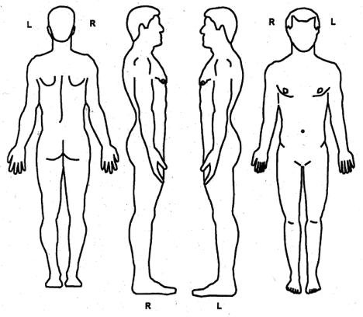

Mark as follows:
A = Ache B = Burning N = Numbness P = Pins & Needles
S = Stabbing O = Other, describe ___________________________________________

Payment Policy

We require payment at the time of service. If you have private health insurance we ask that you pay your co-pay or co-insurance at the time of service. If you have a yearly deductible, you must meet that as your policy specifies. We will bill, or you may bill, your insurance company. If payment for any part of your treatment is denied by an insurance carrier you will assume full responsibility for payment and will pay independent of any appeal process with the insurance carrier.

In the case of either personal injury, auto accident, or workers’ compensation claims, we will bill the entire amount of each visit to your insurance company. Any services not covered by the insurance company are your responsibility. The cost of supplies, supports and/or supplements not paid for by your insurance company are your responsibility.

If you have any questions concerning our payment policy, please feel free to ask the receptionist.

Cancellation Policy

We require 24 hours notice for all cancellations. If you cancel with less than 24 hours notice, you will be charge 50% of the total charges for the scheduled visit. If you fail to keep your appointment and do not call to cancel, you will be charge IN FULL for the total visit. We make reminder calls as a courtesy, however, it is your responsibility to remember and come to your appointments.

******************************************************************************

I have read and understood the above payment and cancellation policies and agree to follow them while utilizing the services at Benessere Chiropractic.

Signed__________________________________ Date_____________

